SANTOS PALYNOLOGY SECTION
EXPLORATION SERVICES DEPARTMENT

Palynology Report No. 2008/04

Author: G.R. WOOD
C. HANNAFORD

Date: 30/5/2008

PALYNOLOGICAL REPORT NO. 2008/04
PALYNOSTRATIGRAPHICAL ANALYSIS

Champion 1

Santos Ltd
A.C.N. 007 550 923

Introduction

Twenty nine cuttings samples from Champion 1, located in the Otway Basin were processed and examined palynologically. In addition preparations from eighteen samples processed in the original palynology study based on sidewall cores (Morgan, 1995) were re-examined.

Champion 1 Palynology Processing Details
S Number | Depth (metres) | No. of Slides | Organic Yield | Sieve size
S11363 | 610 | 1 | Lean | 10
S11364 | 640 | 1 | Lean | 10
S11365 | 670 | 1 | Lean | 10
S11366 | 700 | 2 | Med | 10
S11367 | 730 | 1 | Lean | 10
S11368 | 760 | 2 | Med | 10
S11369 | 790 | 1 | Lean | 10
S11370 | 810 | 1 | Lean | 10
S11371 | 840 | 1 | Lean | 10
S11372 | 870 | 2 | Med | 10
S11373 | 900 | 2 | Rich | 10
S11374 | 930 | 2 | Med | 10
S11375 | 960 | 2 | Med | 10
S11376 | 990 | 3 | Med | 10
S11377 | 1020 | 2 | Med | 10
S11378 | 1050 | 2 | Med | 10
S11379 | 1080 | 2 | Med | 10
S11380 | 1110 | 2 | Med | 10
S11381 | 1140 | 2 | Med | 10
S11382 | 1170 | 2 | Med | 10
S11383 | 1200 | 2 | Med | 10
S11384 | 1220 | 2 | Med | 10
S11385 | 1235 | 2 | Lean | 10
S11386 | 1245 | 2 | Lean | 10
S11387 | 1250 | 1 | Lean | 10
S11389 | 1680 | 3 | Rich | 10
S11390 | 1710 | 3 | Rich | 10
S11392 | 1780 | 1 | Lean | 10
S11393 | 1800 | 1 | Lean | 10

A summary of the palynostratigraphic results is presented in Table 1. A Range Chart of the palynomorphs identified in this study is presented in Appendix 1.

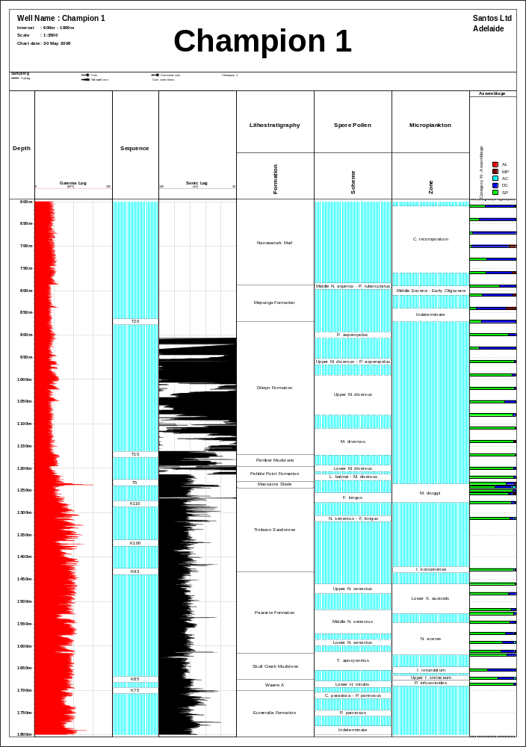
Sample Processing

A critical facet of palynological studies, yet often taken for granted, is processing methods. Good palynological processing is an individualistic art requiring astute skill, knowledge and hands-on involvement.

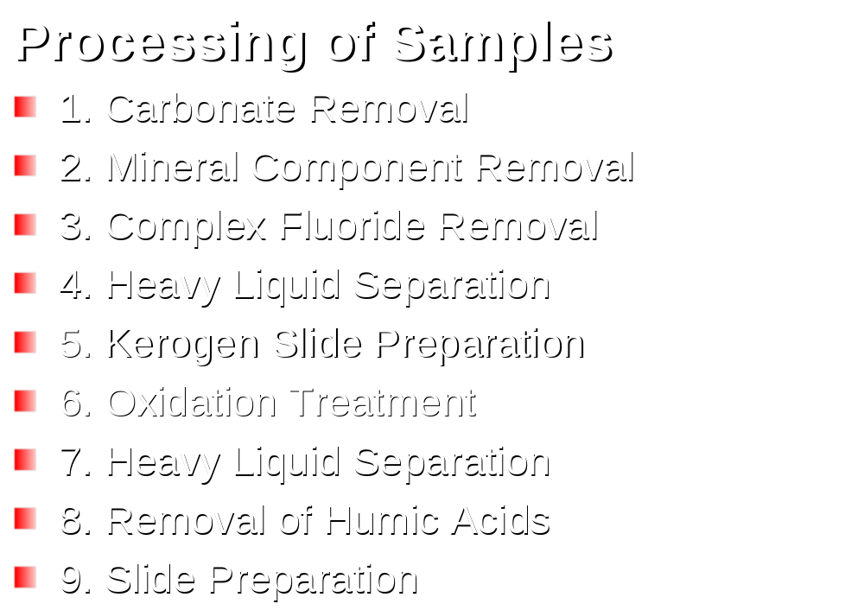

The initial treatment of a prevailingly mineral sample will ordinarily be with hydrofluoric acid to break down siliceous minerals. Concentration of the palynomorphs may then be required for partial elimination of woody fragments, leaf cuticles and amorphous organic matter.

The most commonly needed additional treatment is oxidation to break up massive organic matter to release included palynomorphs or to lighten very dark palynomorphs. This oxidation procedure must be applied as little as possible and with great caution as sporopollenin/chitin are quite oxidation-sensitive themselves. The oxidation makes humic acids available and these must be then removed in basic solution. Sample residues may then be sieved to remove fines and mounted utilising glycerine jelly or other mounting mediums onto glass slides in readiness for examination under the microscope.

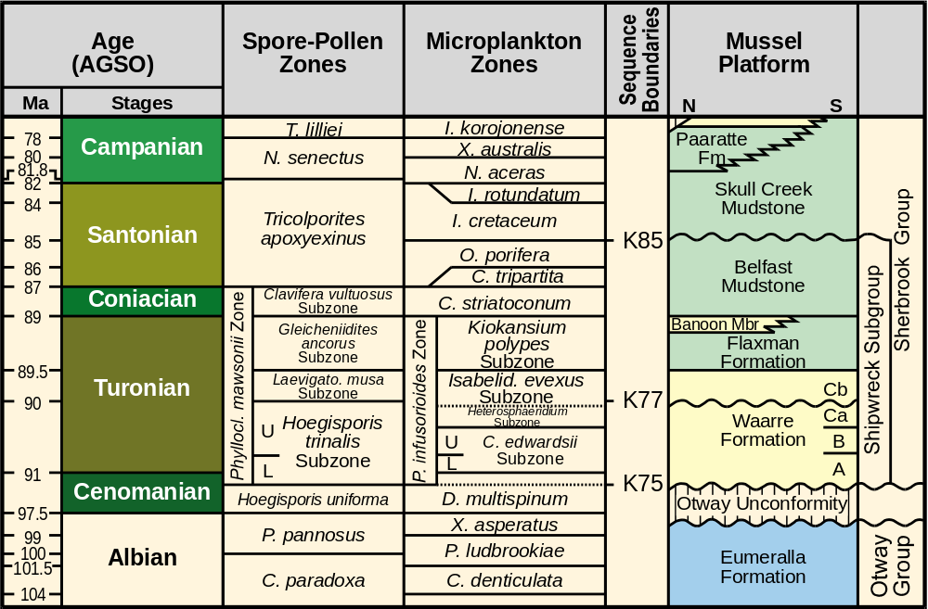

Figure 1: From Sharp & Wood, 2003.

Stratigraphy of the Eastern Mussel Platform.

The stratigraphic succession deposited and preserved over the Mussel Platform comprises sequences from the Early Cretaceous to present day. The stratigraphy herein will concentrate on the economically significant late Cenomanian to Campanian section. Three major sequence boundaries (informally termed K75, K77 and K85 in Santos reports) are responsible for the present day distribution of the reservoir targets across the Mussel Plateau. Stratigraphic discussion will focus on the following chronostratigraphically significant sequences:

Pre K75 : Eumeralla Formation
K75 – K77 Lower to mid Waarre Sandstone
K77 – K85 Upper Waarre to Belfast Mudstone
Post K85 Skull Creek Mudstone and younger

Relationship to the existing lithostratigraphic schemes is based when possible to nomenclature discussed in a revision of the stratigraphy of the Upper Cretaceous Sherbrook Group by Partridge (2001) and an earlier published informal subdivision of the Waarre Sandstone by Buffin (1989). Both of these earlier studies were based on the study of mostly onshore well sequences in the adjoining Port Campbell Embayment. Early Otway Basin stratigraphic frameworks (Bock & Glenie, 1965, Douglas & Ferguson, 1988, Tickell et al, 1992, Moreton et al, 1994) were characterised by markedly diachronous lithological units. Partridge (2001) through utility of improved palynological data for key onshore reference and type sections (Partridge, 1996), proposed a revision of the lithostratigraphic units to more closely represent time-rock units than in previously described schemes (Fig.1).

Biostratigraphic Framework

During the 1980’s most of the palynology undertaken in the Otway Basin was expressed either in terms of the eastern Australian Mesozoic zonation developed by the Minad/APG group (Peter Price and co-workers) or the pan-Australian HMP scheme (Helby, Morgan & Partridge, 1987). Both of these schemes relied on classical interval zone concepts and lacked resolution in the predominantly non-marine to marginal marine Waarre Sandstone and to a certain extent the underlying Eumeralla Formation. By the mid 1990’s the Morgan group had begun to develop an event stratigraphy (Morgan& Hooker in LaBella WCR) and Partridge (2001 Fig.2) published a review and substantial up-date of the Late Cretaceous part of the HMP scheme, introducing a number of subzones based on both interval zone criteria and event features (acmes). The Partridge (2001) Waarre subdivision was based primarily on Port Campbell Embayment on-shore sequences. We have adopted the Partridge scheme but require more precision to satisfactorily label the sands in and below the Waarre “Ca” interval (i.e. below the base of I. evexus) in the offshore Otway sequences with expanded Waarre A to Ca sections. Modifications and further subdivision of the Partridge subzones are outlined in Figure 2.

OTWAY BASIN ZONATION SCHEME FOR THE TURONIAN TO CONIACIAN
Defining Events | Spore Pollen Zones | Microplankton Zones | Defining Events
 | C. vultuosus | Upper C. striatoconus | Top C. striatoconus
Base C. vultuosus | C. vultuosus | Upper C. striatoconus | Base C. striatoconus
Top A. distocarinatus | G. ancoras | Lower C. striatoconus
 | G. ancoras | Lower C. striatoconus | Base G. hymenophora
 | G. ancoras | Lower C. striatoconus | Base Trythyrodinium “marshalii”
 | G. ancoras | K. polypes | Top consistent V. griphus
 | G. ancoras | K. polypes | Base V. griphus, Spinidinium sp A
Top consistent L. musa | L. musa | Upper I. evexus
 | L. musa | Upper I. evexus | Base prominent A. cruciformis
Top consistent H. trinalis | Upper H. trinalis | Lower I. evexus
Base A. obscurus | Upper H. trinalis | Lower I. evexus | Consistent I. evexus
 | Upper H. trinalis | Heterosphaeridium acme Zone | Top prominent Heterosphaeridium
 | Upper H. trinalis | Heterosphaeridium acme Zone | Base prominent Heterosphaeridium
Base  consistent P. mawsonii | Upper H. trinalis | Upper C. edwardsii | Base I. evexus / “waarriense”
Base consistent L. musa | Lower H. trinalis | Upper C. edwardsii | Base consistent K. polypes, Heterosphaeridium spp, prominent C. edwardsii
 | Lower H. trinalis | Lower C. edwardsii
 | Lower H. trinalis | Lower C. edwardsii | Base dinoflagellates
Base H. trinalis, V. admirabilis, L.musa, C. triplex, P. mawsonii / eunichus | Lower H. trinalis

Figure 2
Palaeoenvironmental Analysis
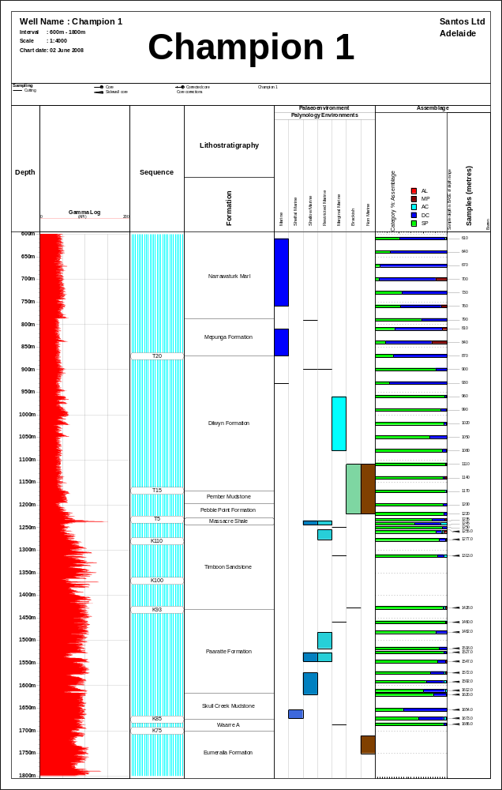
Definition of palaeoenvironments used in this study

Non-marine – No marine influence (nil or only monospecific proximal dinocyst component) - fluvial, swamp, lacustrine, coastal plain

Marginal Marine – paralic environments with an interaction of freshwater influx and marine influence (low yield, very low diversity microplankton assemblages) – upper delta plain, coastal lagoon, estuarine.

Restricted Marine –marine environment influenced by higher salinities, freshwater influx or turbidity (moderate yield, low diversity microplankton assemblages) – estuarine, lower delta plain, inner to middle neritic environments.

Shallow Marine – fully marine environment with minimum freshwater influence (low to moderate yields, moderate to high diversity assemblages) – inner to middle neritic environments.

Shelfal Marine - fully marine environment with minimum freshwater influence (moderate to high yields, moderate to high diversity assemblages) –middle to outer neritic environments.

Palaeoenvironmental Analyses

The analysis of the relative abundances of spore and pollen grains, dinoflagellates and acritarchs in assemblages can provide useful palaeonenvironmental data.Plots of relative abundances of palynomorph groups can be related to transgressive-regressive phases and distances from the shoreline. The most commonly measured ratio is that of the marine (dinoflagellates + acritarchs) versus terrestrial (spores + pollen) palynomorphs.

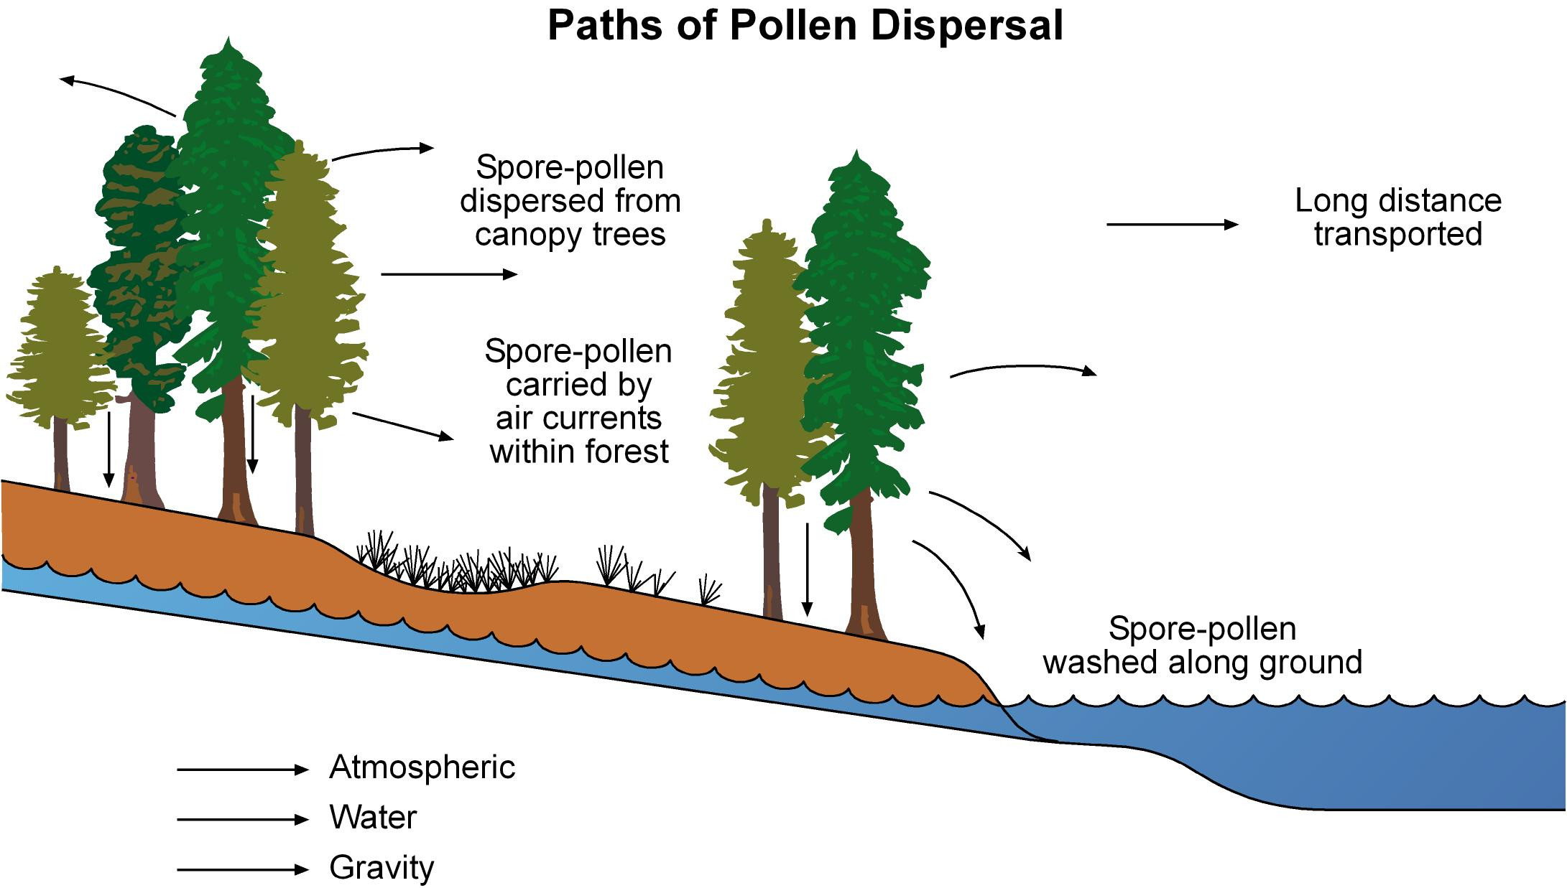

Relative proportions of spores (ferns, lycopods & bryophytes), pollen (gymnosperm & angiosperm) in the terrestrial component can provide evidence of the floristic composition of the depocentre and its surrounding hinterland.

Organic-walled cyst producing dinoflagellates can provide evidence of the surface water physio-chemical conditions in marine influenced depositional settings. Modern and Quaternary dinocyst studies indicate that the cyst-forming dinoflagellates principally thrive in relatively shallow marine environments with their highest diversities reached along shelves and continental rises (Dale, 1996). Studies on the distribution pattern of modern dinocysts have shown that apart from nutrient availability and water temperature, cyst diversity strongly depends on the relative stress (turbidity & salinity) in the ecosystem. As these stress elements are often related to shoreline proximity, the dinocyst diversity signal is a useful palaeoenvironmental indicator (Pross & Brinkhuis, 2005).

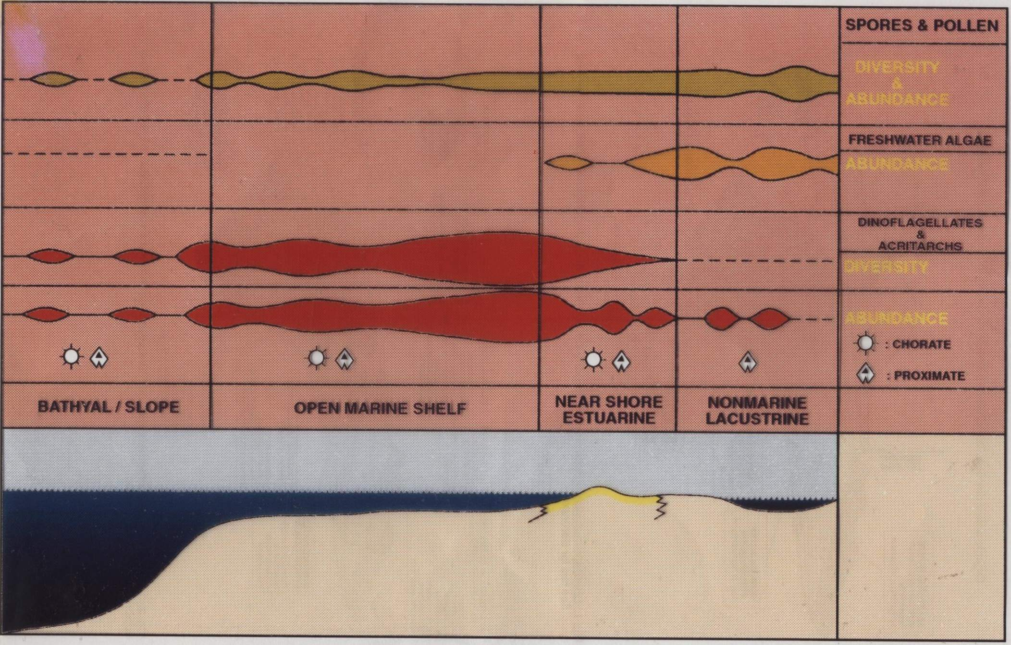

The proximal / distal signal is expressed by changes in the assemblage composition, assemblage diversity and cyst abundances.

Actuopalaeontological and Quaternary studies as well as more recently dinocyst ecobiostratigraphic studies in Tertiary basins (Pross & Brinkhuis, 2005; Sluijs, et al, 2005) have refined existing and furnished new concepts of palaeoenvironmental reconstructions utilising dinocysts. Analysis of Paleogene dinocyst assemblages have been integrated with models of sea-surface productivity, temperature, salinity and stratification (Sluijis et al, 2005).

Similar ecobiostratigraphic studies of Cretaceous dinocyst assemblages are rare. A high resolution, quantitative study of Late Cretaceous assemblages from the Western Interior Basin, USA by Harris & Tocher (2000) identified criteria for discerning salinity contrasts across the basin. There are some common elements in the Late Cretaceous assemblages in the Otway Basin.

PALYNOLOGY
SAMPLE DATA
Santos CHAMPION 1
PALYNOSTRATIGRAPHICAL REPORT
Palynologist: Wood/Hannaford Page 1 of 7
Sample | Depth | Palynostratigraphical | Formation | Reworked elements |  | Preservation | Diversity | Remarks
 | (Metres) | unit (Age) |  | % | age
CUTTS | 610 | ?C. incompositum  (Late Eocene – Early Oligocene) | Mepunga Formation to Narrawaturk Marl |  |  | Good | Mod | Mainly dinoflagellates. Presence of S. speciosus and absence of older and younger markers. Miocene cavings noted.
CUTTS | 640 | Middle Eocene to Early Oligocene (undiff.) | Mepunga Formation to Narrawaturk Marl |  |  | Good | Low | No marker species present. Miocene cavings noted.
CUTTS | 670 | ?C. incompositum  (Late Eocene – Early Oligocene) | Mepunga Formation to Narrawaturk Marl |  |  | Good | Mod | Mainly dinoflagellates. Presence of T. pelagica and absence of older and younger markers. Miocene cavings noted.
CUTTS | 700 | Middle Eocene to Early Oligocene (undiff.) | Mepunga Formation to Narrawaturk Marl |  |  | Good | Low | Mainly long ranging Middle Eocene to Early Oligocene dinoflagellates.
CUTTS | 730 | Middle Eocene to Early Oligocene (undiff.) | Mepunga Formation to Narrawaturk Marl |  |  | Good | Mod | Mainly long ranging Middle Eocene to Early Oligocene dinoflagellates.
CUTTS | 760 | ?C. incompositum  (Late Eocene – Early Oligocene) | Mepunga Formation to Narrawaturk Marl |  |  | Good | Mod | Mainly long ranging Middle Eocene to Early Oligocene dinoflagellates. Presence of S. speciosus and absence of older and younger markers.
CUTTS | 790 | Mid N. asperus – P. tuberculatus  (Late Eocene – Oligocene) | Mepunga Formation to Narrawaturk Marl |  |  | Good | Low | Lean. Presence o f P. rectomarginus with D. granulatus and A. qualumis.
Santos CHAMPION 1
PALYNOSTRATIGRAPHICAL REPORT
Palynologist: Wood/Hannaford Page 2 of 7
Sample | Depth | Palynostratigraphical | Formation | Reworked elements |  | Preservation | Diversity | Remarks
 | (Metres) | unit (Age) |  | % | age
CUTTS | 810 | Middle Eocene to Early Oligocene (undiff.) | Mepunga Formation to Narrawaturk Marl |  |  | Good | Mod | Presence of M. diversus and increased Nothofagidites.heterus / emarcidus in the spore pollen component.
CUTTS | 840 | Indeterminate |  |  |  | Good | Low | Lean. No markers present.
CUTTS | 870 | Indeterminate |  |  |  | Good | Low | Lean. No markers present. Increased woody material from here down.
CUTTS | 900 | ?P. asperopolus  (Middle Eocene) | Dilwyn Fm |  |  | Good | Mod. | Presence P. pachypolus, P. grandis, M. diversus, P. tuberculatus and P. reticulatus. H. harrisii > Nothofagidites spp. & Malvacipollis spp
CUTTS | 930 | Indeterminate |  |  |  | Good | Low | Lean. No markers present.
CUTTS | 960 | Upr M. diversus – P. asperopolus  (Early – Middle Eocene) | Dilwyn Fm | 1 | Perm. | Good | Mod. | Presence of frequent M. diversus, with P. pachypolus, P. grandis, P. tuberculatus, I. notabilis, P. tuberculiformis and P. demarcartus.
CUTTS | 990 | Upr M. diversus  (Early Eocene) | Dilwyn Fm | 1 | Perm. | Good | Mod. | Presence of frequent M. diversus, with, P. grandis, I. notabilis and P. demarcartus. Deflandrea robusta also noted.
CUTTS | 1020 | Upr M. diversus  (Early Eocene) | Dilwyn Fm | 1 | Perm. | Good | Mod. | Presence of frequent M. diversus, with M. tenuis, C. cainozoicus and P. demarcatus.

Santos CHAMPION 1
PALYNOSTRATIGRAPHICAL REPORT
Palynologist: Wood/Hannaford Page 3 of 7
Sample | Depth | Palynostratigraphical | Formation | Reworked elements |  | Preservation | Diversity | Remarks
 | (Metres) | unit (Age) |  | % | age
CUTTS | 1050 | Upr M. diversus  (Early Eocene) | Dilwyn Fm |  |  | Good | Mod | Presence of frequent M. diversus with I. notabilis and P. demarcartus.
CUTTS | 1080 | Upr M. diversus  (Early Eocene) | Dilwyn Fm | 1 | Perm. | Good | Mod | Presence of frequent M. diversus with P. demarcartus.
CUTTS | 1110 | M. diversus  (Early Eocene) | Pember Mudstone to Dilwyn Fm | 1 | Perm. | Good | Mod | Presence of M. diversus with P. demarcartus.
CUTTS | 1140 | M. diversus  (Early Eocene) | Pember Mudstone to Dilwyn Fm | 2 | Perm. | Good | Mod | Presence of frequent M. diversus with P. demarcartus and P. grandis.
CUTTS | 1170 | M. diversus  (Early Eocene) | Pember Mudstone to Dilwyn Fm |  |  | Good | Mod | Presence of frequent M. diversus with P. demarcartus and P. grandis.
CUTTS | 1200 | Lwr M. diversus  (Early Eocene) | Pember Mudstone to Dilwyn Fm |  |  | Good | Mod. | Presence of frequent M. diversus with I. notabilis. D. pachyceras dinoflagellate also noted.
CUTTS | 1220 | L. balmei to M. diversus  (Palaeocene to E. Eocene) | Pebble Point Formation to Pember Mudstone |  |  | Good | V. low | Sparse, restricted assemblage with long ranging Tertiary forms including common H. harrisii and M. diversus.
CUTTS | 1235 | M. druggii  (Maastrichtian) | Upper Timboon to Massacre Shale |  |  | Good | V. low | Sparse, restricted assemblage. Rare dinoflagellates noted including M. conorata.
CUTTS | 1245 | M. druggii  (Maastrichtian) | Upper Timboon to Massacre Shale |  |  | Good | Ext. low | Extremely sparse, restricted assemblage. Rare dinoflagellates noted including M. conorata.

Santos CHAMPION 1
PALYNOSTRATIGRAPHICAL REPORT
Palynologist: Wood/Hannaford Page 4 of 7
Sample | Depth | Palynostratigraphical | Formation | Reworked elements |  | Preservation | Diversity | Remarks
 | (Metres) | unit (Age) |  | % | age
CUTTS | 1250 | M. druggii  (Maastrichtian) | Upper Timboon to Massacre Shale |  |  | Good | V. low | Sparse, restricted assemblage. Rare dinoflagellates noted including M. conorata.
SWC | 1255 | M. druggii, F. longus  (Maastrichtian) | Upper Timboon to Massacre Shale | 3 | Perm. | Good | Mod. | M. druggii & M. conorata prominent, G. rudata frequent, F. sabulosus & T. maastrichtiensis present.
SWC | 1277 | M. druggii, F. longus  (Maastrichtian) | Upper Timboon to Massacre Shale | + | Perm. | Good | Mod. | M. conorata & C. bretonica present, G. rudata frequent, F. sabulosus & F. longus present.
SWC | 1313 | N. senectus to F. longus  (Campanian) | Skull Creek Mudstone to Massacre Shale |  |  | Good | Ext. low | Extremely sparse, restricted assemblage. Rare dinoflagellates & Nummus spp noted. N. endurus & F. sabulosus present.
SWC | 1428 | I. korojonense  (Campanian) | Lower Timboon | 2 | Perm. | Good | Low | I. korojonense present, F. sabulosus, G. rudata & ?B. sectilis noted.
SWC | 1460 | Lwr X. australis, Upr N. senectus  (Campanian) | Skull Creek Mudstone to Paaratte Formation | + | Perm. | Good | Mod. | X. australis, O. porifera & N. semireticulata present in the sparse microplankton component (1%). G. rudata, N. senectus & F. sabulosus are key spore pollen components.
SWC | 1482 | Lwr X. australis, Upr N. senectus  (Campanian) | Skull Creek Mudstone to Paaratte Formation |  |  | Good | Mod. | X. australis (12%), O. porifera, M. pentagonum & N. tuberculata present in the microplankton component (16%). G. rudata, N. senectus & F. sabulosus are key spore pollen components.
SWC | 1518 | Lwr X. australis, Middle N. senectus  (Campanian) | Skull Creek Mudstone to Paaratte Formation |  |  | Good | Mod. | X. australis (7%), O. porifera, M. pentagonum & N. tuberculata present in the microplankton component (11%). G. rudata, N. senectus & F. sabulosus are key spore pollen components.

Santos CHAMPION 1
PALYNOSTRATIGRAPHICAL REPORT
Palynologist: Wood/Hannaford Page 5 of 7
Sample | Depth | Palynostratigraphical | Formation | Reworked elements |  | Preservation | Diversity | Remarks
 | (Metres) | unit (Age) |  | % | age
SWC | 1527 | Lwr X. australis, Middle N. senectus  (Campanian) | Skull Creek Mudstone to Paaratte Formation | 1 | Perm. | Good | Mod. | X. australis (1%), M. pentagonum, N. aceras & N. tuberculata present in the low microplankton component (4%).F. sabulosus is the key spore pollen component.
SWC | 1547 | Upr N. aceras, Middle N. senectus  (Campanian) | Skull Creek Mudstone to Paaratte Formation | 1 | Perm. | Good | Mod. | N. aceras & N. tuberculata present in the low diversity microplankton component (11%).F. sabulosus is the key spore pollen component.
SWC | 1572 | Upr N. aceras, Middle N. senectus  (Campanian) | Skull Creek Mudstone to Paaratte Formation | 2 | Perm. | Good | Mod. | N. aceras & N. tuberculata present in the microplankton component (19%).F. sabulosus is the key spore pollen component.
SWC | 1592 | Lwr N. aceras, ?Lwr N. senectus  (Campanian) | Skull Creek Mudstone to Paaratte Formation | + | Perm. | Good | Mod. | Common Heterosphaeridium spp.(19%),N. aceras, I. belfastense, I. cretaceum, I. rotundatum & thick Trithyrodinium spp present in the microplankton component (25%).
SWC | 1612 | Lwr N. aceras, Upr T. apoxyexinus  (Santonian) | Skull Creek Mudstone to Paaratte Formation |  |  | Good | Mod. | Common Heterosphaeridium spp.(18%),N. aceras & thick Trithyrodinium spp present in the microplankton component (30%). Proteacidites spp (15 %)are a prominent component of the spore pollen.
SWC | 1620 | Lwr N. aceras, Upr T. apoxyexinus  (Santonian) | Skull Creek Mudstone to Paaratte Formation |  |  | Good | Mod. | Frequent Heterosphaeridium spp.(12%),N. aceras & I. cretaceum present in the microplankton component (18%). Proteacidites spp (16 %) are a prominent component of the spore pollen.

Santos CHAMPION 1
PALYNOSTRATIGRAPHICAL REPORT
Palynologist: Wood/Hannaford Page 6 of 7
Sample | Depth | Palynostratigraphical | Formation | Reworked elements |  | Preservation | Diversity | Remarks
 | (Metres) | unit (Age) |  | % | age
SWC | 1654 | I. rotundatum, Upr T. apoxyexinus  (Santonian) | Skull Creek Mudstone to Paaratte Formation |  |  | Good | Mod. | Abundant Heterosphaeridium spp.(41%),I. rotundatum, I. belfastense, A. denticulata & I. cretaceum present in the microplankton component (61%). Proteacidites spp (12 %) are a prominent component of the spore pollen.
SWC | 1673 | Upr I. cretaceum,  (Santonian) | Skull Creek Mudstone to Paaratte Formation | 1 | Perm. | Good | Mod. | Abundant Heterosphaeridium spp.(30%),O. porifera, I. rectangulare & I. cretaceum present in the microplankton component (35%). Proteacidites spp (1%) & P. gillii are components of the spore pollen.
CUTTS | 1680 | P. infusorioides Zone, C. edwardsii Subzone  (Turonian) | Waarre Sandstone | 5 | Perm. | Fair | Low | Mixed assemblage. Abundant Santonian components including N. aceras, O. costata & Heterosphaeridium spp. Turonian elements include C. edwardsii.
SWC | 1686 | P. infusorioides Zone, Lwr C. edwardsii Subzone, P. mawsonii Zone, Lwr H. trinalis Subzone  (Turonian) | Waarre Sandstone A |  |  | Good | Mod. | Spore pollen abundant including C. triplex, A. distocarinatus, P. mawsonii, T. trioreticulosus & H. trinalis. Low diversity microplankton component (5%) including C. edwardsii, K. polypes & C. distinctum.
CUTTS | 1710 | ?C. paradoxa to P. pannosus  (Albian) | ? Eumeralla Formation |  |  | Good | Low | Cyathidites spp abundant, bisaccate pollen common, C. paradoxa, T. reticulatus, C. hughesii, Cicatricosisporites sp. 1175 & T. trioreticulatus prominent. Appears non marine apart from obvious Santonian cavings contaminants.
SWC | 1712 | C. paradoxa to P. pannosus  (Albian) | Eumeralla Formation |  |  | Good | Low | Cyathidites spp abundant, Corollina spp & M. antarcticus frequent, C. paradoxa, T. reticulatus, C. hughesii, Cicatricosisporites sp. 1175 & C. striatus present.

Santos CHAMPION 1
PALYNOSTRATIGRAPHICAL REPORT
Palynologist: Wood/Hannaford Page 7 of 7
Sample | Depth | Palynostratigraphical | Formation | Reworked elements |  | Preservation | Diversity | Remarks
 | (Metres) | unit (Age) |  | % | age
SWC | 1751 | P. pannosus  (Albian) | Eumeralla Formation |  |  | Good | Low | Cyathidites spp abundant, P. pannosus prominent, C. paradoxa, T. reticulatus, A. spinulosus, Cicatricosisporites sp. 1175 & C. striatus present.
CUTTS | 1780 | Indeterminate | - |  |  | Fair | Ext. low | Extremely sparse ?Early Cretaceous assemblage with abundant Santonian cavings contaminant component.
CUTTS | 1800 | Indeterminate | - |  |  | Fair | Ext. low | Extremely sparse ?Early Cretaceous assemblage with abundant Santonian cavings contaminant component.

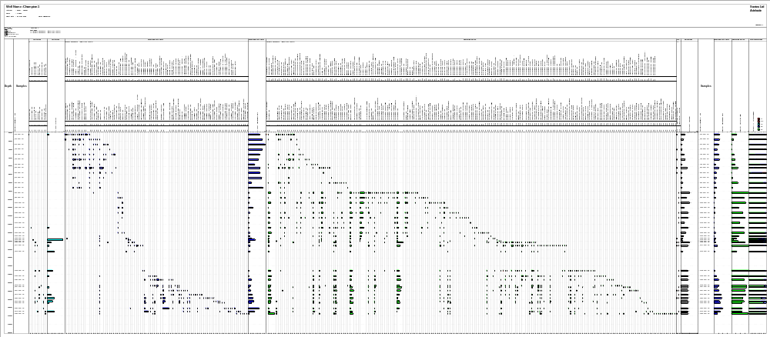
References

Bock, P.E. & Glenie R.C. 1965. Late Cretaceous and Tertiary depositional cycles in south-western Victoria, Proceedings Royal Society of Victoria, 79 (1), 153-163.

Buffin, A.J. 1989. Waarre Sandstone development within the Port Campbell Embayment, The APEA Journal, 29 (1), 299-311.

Dale, B. 1996. Dinoflagellate cyst ecology: Modelling and geological applications. – In: Jansonius, J. & McGregor, D.C., Eds., Palynology:Principles and Applications: 1249-1276, Dallas (American Association of Stratigraphic Palynologists Foundation).

Douglas, J.G. & Ferguson J.A. (Eds) 1988 Geology of Victoria. Victorian Division, Geological Society of Australia Incorporated, Melbourne, 665p.

Harris, A.J. & Tocher, B.A. 2003. Palaeoenvironmental analysis of Late Cretaceous dinoflagellate cyst assemblages using high resolution sample correlation from the Western Interior Basin, USA. Marine Micropaleontology 48; 127-148.

Helby, R.J., Morgan, R. & Partridge, A.D. (1987) A palynological zonation of the Australian Mesozoic. In: Jell: (Ed.) Studies in Australian Mesozoic Palynology. Association of Australasian Palaeontologists Memoir 4. 1-94.

Moreton, J.G.G., Hill, A.J., Parker, G. & Tabassi, A. 1994. Towards a unified stratigraphy for the Otway Basin, in Finlayson D.M. (compiler), NGMA/PESA Otway Basin Symposium, Melbourne, extended abstracts.

Partridge, A.D. 1994. Palynological analysis of Langley-1, Port Campbell Embayment, Otway Basin. Biostrata Report 1994/11, unpublished.

Partridge, A.D. 1999. Late Cretaceous to Tertiary geological evolution of the Gippsland Basin, Victoria. Latrobe University PhD Thesis (unpublished).

Partridge, A.D. 2001. Revised stratigraphy of the Sherbrook Group, Otway Basin. PESA Eastern Australian Basins Symposium, p455-465.

Pross, J. & Brinkhuis, H. 2005. Organic-walled dinoflagellate cysts as paleoenvironmental indicators in the Paleogene; a synopsis of concepts.

Sharp, N.C. & Wood G.R. 2004. Casino Gas Field, offshore Otway Basin, Victoria – the appraisal story and some stratigraphic enlightenment. PESA Eastern Australian Basins Symposium, p1-14.

Sluijs, A., Pross, J. & Brinkhuis, H. 2005. From greenhouse to icehouse; organic walled dinoflagellate cysts as paleoenvironmental indicators in the Paleogene. Earth Science Reviews 68: 281-315.

Tickell, S.J., Edwards, J. & Abele, C. 1992. Port Campbell Embayment 1:100,000 map geological report. Geological Survey of Victoria Report, 95, 1-97.

